FINAL PROJECT DOCUMENT
SAMSUNG INOVATION CAMPUS

GROUP 17

1. Data Files
1.1 Retail Prices Dataset
- Source: Public UK supermarket price time-series dataset (HuggingFace, pre-downloaded locally).
- File format: Parquet (uk_retail_with_city.parquet)
- Main columns:
  - supermarket_name
  - price_gbp
  - price_unit_gbp
  - unit
  - product_name
  - capture_date
  - category_name (fresh_food, food_cupboard, health_products, drinks, home, household, frozen, bakery, baby_products, etc.)
  - is_own_brand
  - city
This dataset represents the retail side of the problem: what products are sold, at what price, in which city, and when.

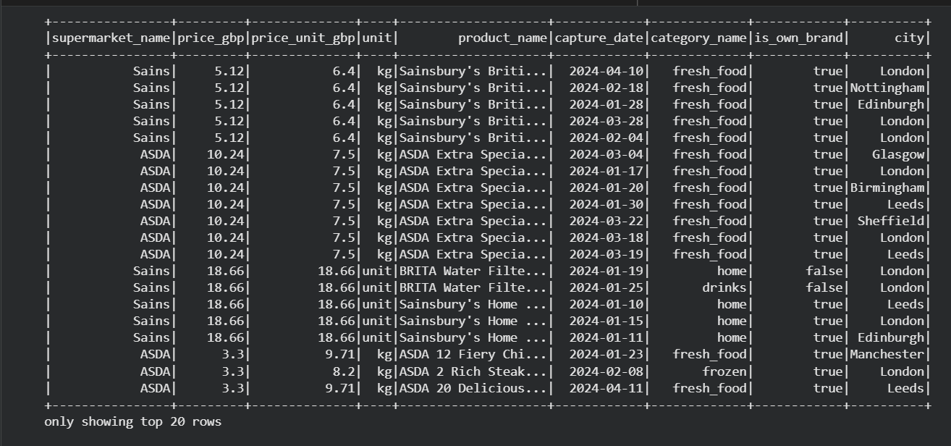

1.2 Weather Dataset
- Source: NOAA GHCN Daily by year.
- Files:
  - 2024.csv / 2024.csv.gz
- Main columns (after parsing):
  - Station_ID
  - Date (YYYYMMDD)
  - Element (TMAX, TMIN, TAVG, PRCP, and many other codes)
  - Value (measurement, e.g. tenths of °C or tenths of mm)
  - Quality flags, source flags, etc.
This dataset represents the weather side of the problem: daily temperature and precipitation for many stations in the UK.

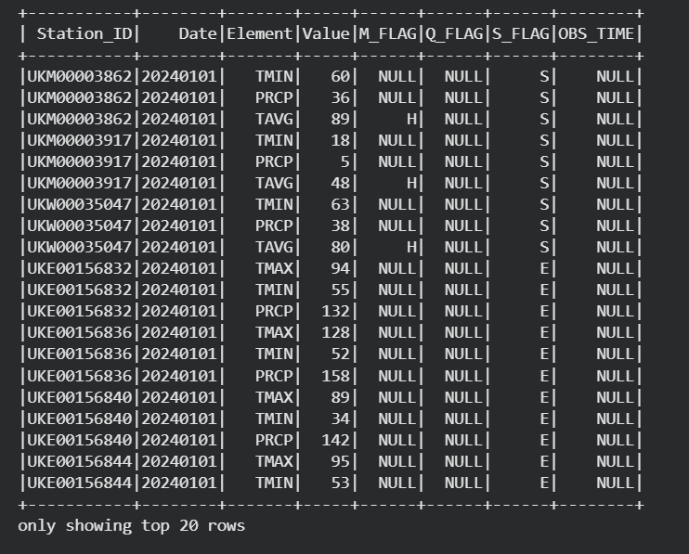

  - UK Cities Reference Dataset

- Source: Public world cities dataset filtered down to cities in the United Kingdom.
- File format: CSV (<gb.csv>)
- Main columns:
- city
- lat
- lng
- country
- iso2
- admin_name
- capital
- population
- population_proper

This dataset provides a reference list of UK cities with their latitude/longitude, basic
administrative information, and population. It is used to map each retail record
(coming with coordinates) to the nearest city centre and to derive a clean `city` /
`city_clean` attribute for downstream joins with weather data.

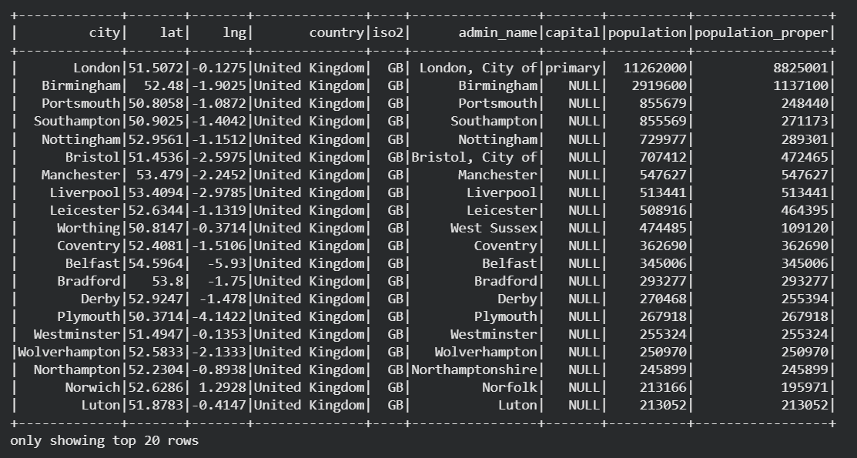
  - Station Metadata (GHCND Stations)

- Source: NOAA GHCN station metadata file.
- File format: TXT (ghcnd-stations.txt)
- Main columns (after parsing):
- station_id
- latitude
- longitude
- elevation_m
- station_name

This dataset contains the geographic metadata for all GHCND weather stations worldwide.
It is used to attach coordinates and basic descriptions to the `Station_ID` values
found in `2024.csv`, and to filter/select only stations that fall within the UK
geographic area before aggregating weather to city level.

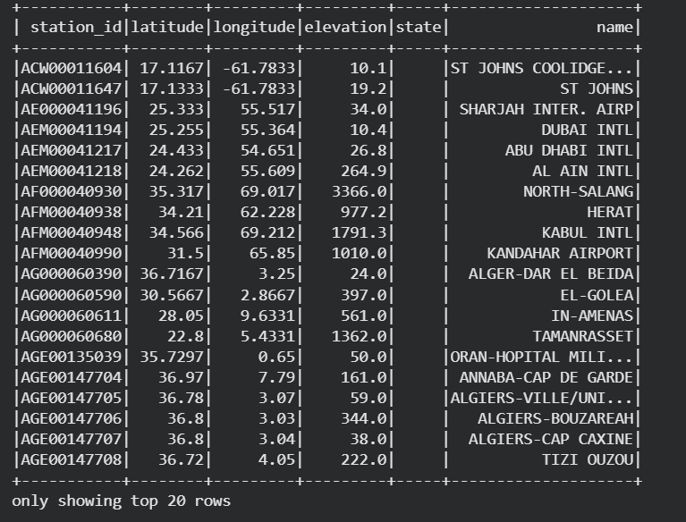

2. Big Data Environment (Docker Cluster)
All components run inside a Docker Compose cluster:
- HDFS and YARN:
  - namenode
  - datanode
  - resourcemanager
  - nodemanager
- Hive + Metastore
- Spark
- Apache Airflow
- Newly added: Apache NiFi container
- The NiFi service is attached to the same Docker network 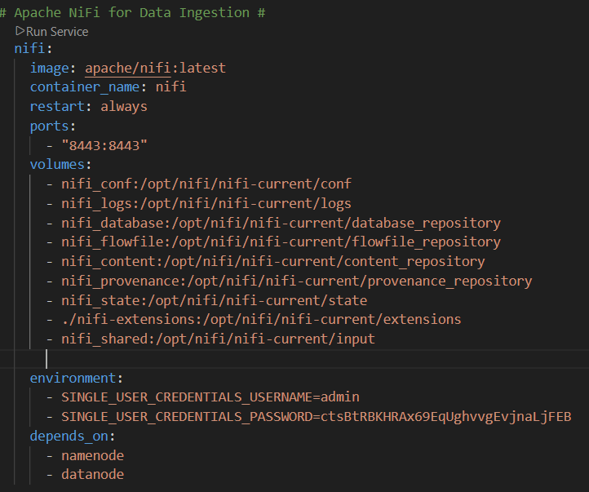
- Copy Hadoop configuration files (core-site.xml, hdfs-site.xml) to NiFi container so that NiFi can write directly to HDFS.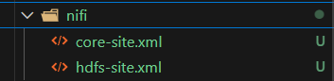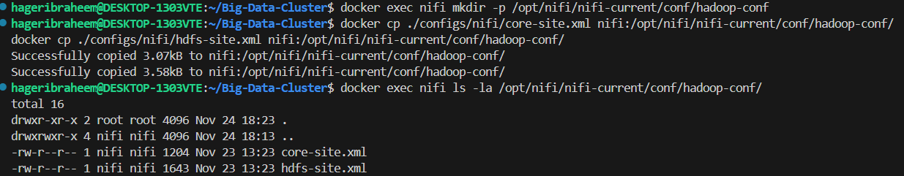
- Since we use NiFi 2.0, HDFS processors need to manually install and add them.
the required NAR files (these are the processor libraries):
- nifi-hadoop-nar
- Nifi-hadoop-libraries-nar
Steps to install these libraries:
1. Make ‘nifi-extensions’ directory and install using ‘wget’ command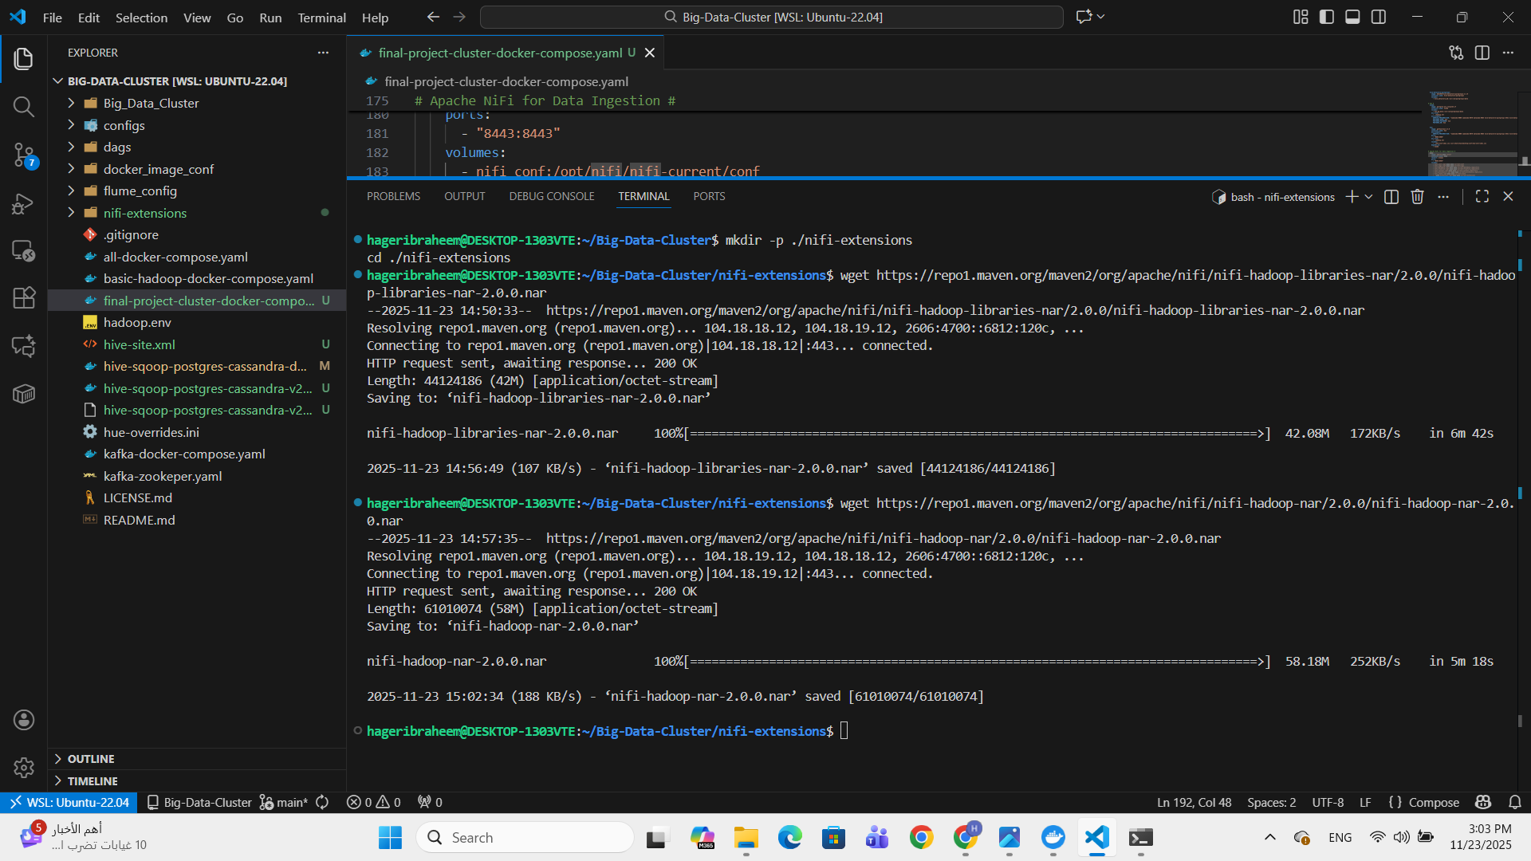
2. Copy libraries to NiFi container
This setup simulates a small big-data platform on a single machine.

3. Ingestion with Apache NiFi
3.1 Goal
Instead of loading data directly from local files into Spark, we use NiFi as an ingestion layer integrates with Airflow to:
- Move raw files from the host machine into the cluster.
- Land them in HDFS “raw zone” in a consistent folder structure.
- Make the pipeline reproducible and easy to extend.
3.2 Copying Files into the NiFi Container
On the host, data files (downloaded from the internet) live in e.g.:
- C:\Users\<user>\Downloads\2024.csv
- C:\Users\<user>\Downloads\uk_retail_with_city.parquet
- C:\Users\<user>\Downloads\ ghcnd-stations.txt
- C:\Users\<user>\Downloads\ gb.csv

They are copied into the NiFi container using Airflow task, into a dedicated ‘input’ directory:
1. Make volume in namenode container where Airflow running for the directory contains data in local machine
2. Make volume in NiFi container for ‘input’ directory where data would copy into it
3. Share that volume in the namenode container so Airflow can write directly to it
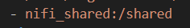
4. Create Airflow task to send data to NiFi
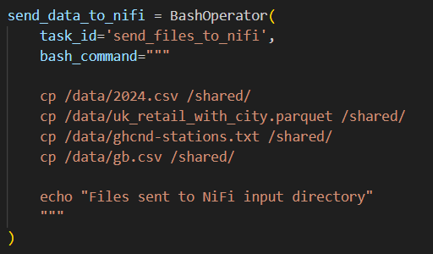
Inside the container, NiFi watches /opt/nifi/nifi-current/input/.

3.3 NiFi Flow
For each dataset we define a simple process group:
- GetFile
  - Input Directory: /opt/nifi/nifi-current/input
  - Picks up the CSV ,parquet and txt files dropped into that folder.
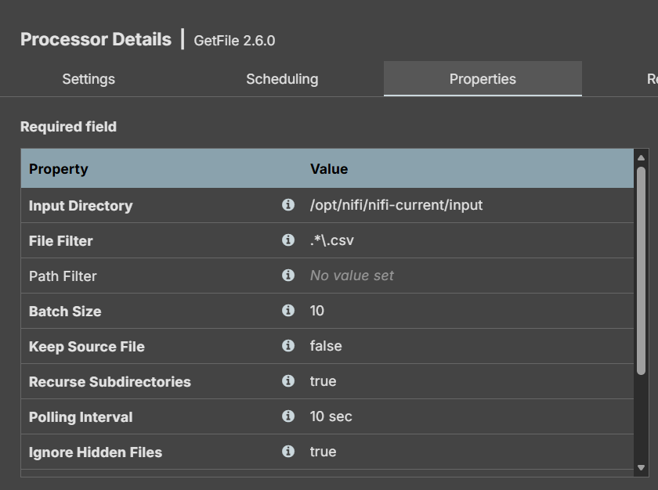
- PutHDFS
  - Uses Hadoop configuration files from the mounted directory (paths like
/opt/nifi/nifi-current/conf/hadoop-conf/core-site.xml and hdfs-site.xml).
  - Writes files into HDFS raw zone, for example:
    - Weather: hdfs://namenode:9000/staging_zone/nifi/weather_sales_data/2024.csv
    - Retail: hdfs://namenode:9000/staging_zone/nifi/weather_sales_data/uk_retail_with_city.parquet
    - Stations: hdfs://namenode:9000/staging_zone/nifi/weather_sales_data/ ghcnd-stations.txt
    - Cities:
hdfs://namenode:9000/staging_zone/nifi/weather_sales_data/ gb.csv
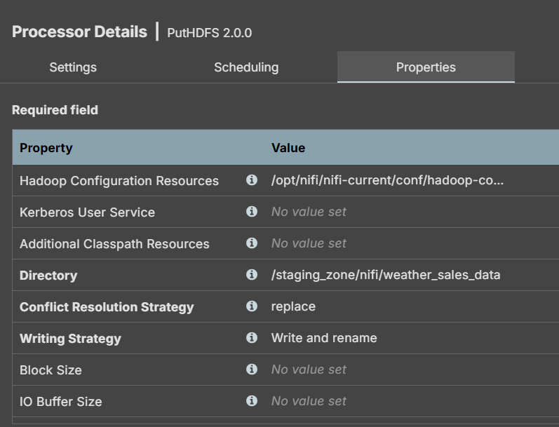
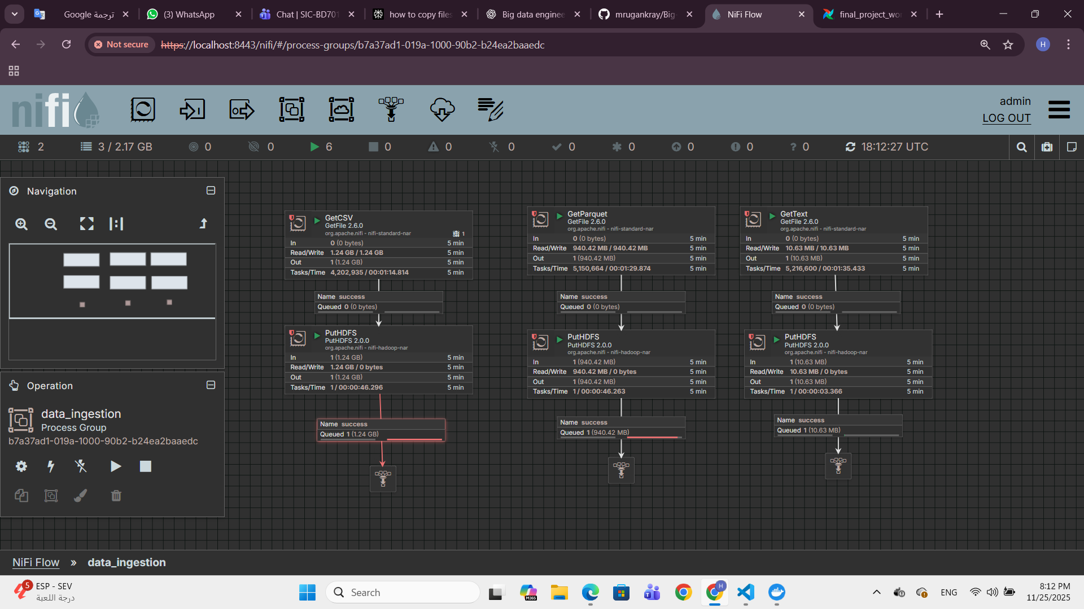

4. Raw Data Layout in HDFS
After NiFi ingestion, HDFS contains raw, untouched copies of the source data:
- /staging_zone/nifi/weather_sales_data/2024/2024.csv
- /staging_zone/nifi/weather_sales_data/uk_retail_with_city.parquet
- /staging_zone/nifi/weather_sales_data/ ghcnd-stations.txt
- /staging_zone/nifi/weather_sales_data/ gb.csv

These paths act as the “data lake raw layer”; we never modify these files. All transformations happen downstream in Spark.

5.Transformations
The code snippets shown in this section highlight only the main transformation steps applied to the weather and retail datasets (cleaning, enrichment, joins, and star-schema creation). They are not the full implementation.
The complete PySpark notebook, including all helper cells, exploratory steps, and additional checks, is provided in the appendix .

5.1. Weather data cleaning – drop unnecessary columns

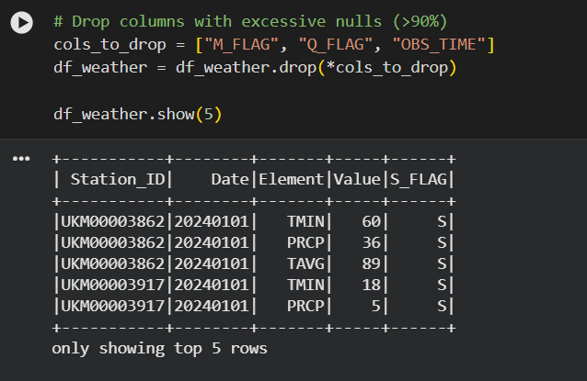
Remove highly sparse and non-essential columns from the daily weather observations:
- M_FLAG (measurement flag)
- Q_FLAG (quality flag)
- OBS_TIME (observation time)
• These columns contain mostly null values and are not needed for downstream analysis.
• The cleaned weather DataFrame is kept in df_weather.

5.2. Retail data cleaning – remove duplicates and nulls

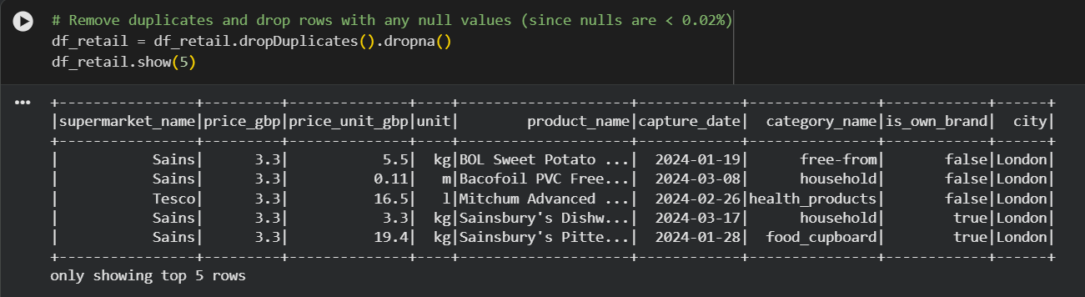
- Deduplicate the retail dataset by dropping any exact duplicate rows.
- Remove rows that contain nulls in any column.
- This is acceptable because the overall null rate is very low (<0.02%), so dropping those rows does not materially impact the dataset.
5.3. Clean & pivot weather data to daily station-level metrics
- Convert the raw Date column (integer-like yyyyMMdd) into a proper DateType.
- Pivot the long-format GHCN weather table into a wide station-day table, with one row per (Station_ID, Date):
  - Use Element values (TMAX, TMIN, PRCP, TAVG) as columns.
  - Aggregate by avg(Value) in case there are multiple records per day.
- Convert raw measurement units from tenths to real values:
  - TMAX, TMIN, TAVG from tenths of °C to °C.
  - PRCP from tenths of mm to mm.
- Replace any missing PRCP with 0, assuming no recorded precipitation means no rain.
- If TAVG (average temperature) is missing, recompute it as the rounded mean of TMAX and TMIN.

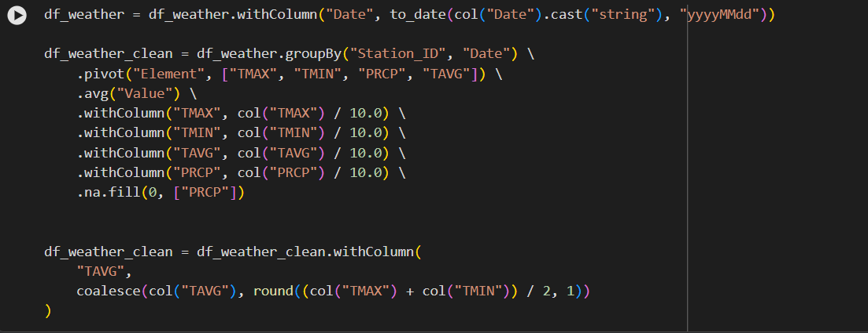

5.4. Transform retail data – derive quantity and calendar flags.
Enrich retail transactions with derived fields:
  - quantity: approximate number of units sold, computed as
ceil (price_gbp / price_unit_gbp).
  - day_name: short name of the weekday (e.g. Mon, Tue, …) from capture_date.
  - is_weekend: binary flag (1 for Saturday/Sunday, 0 otherwise).
- The resulting DataFrame df_retail_enriched is the main retail dataset used downstream.
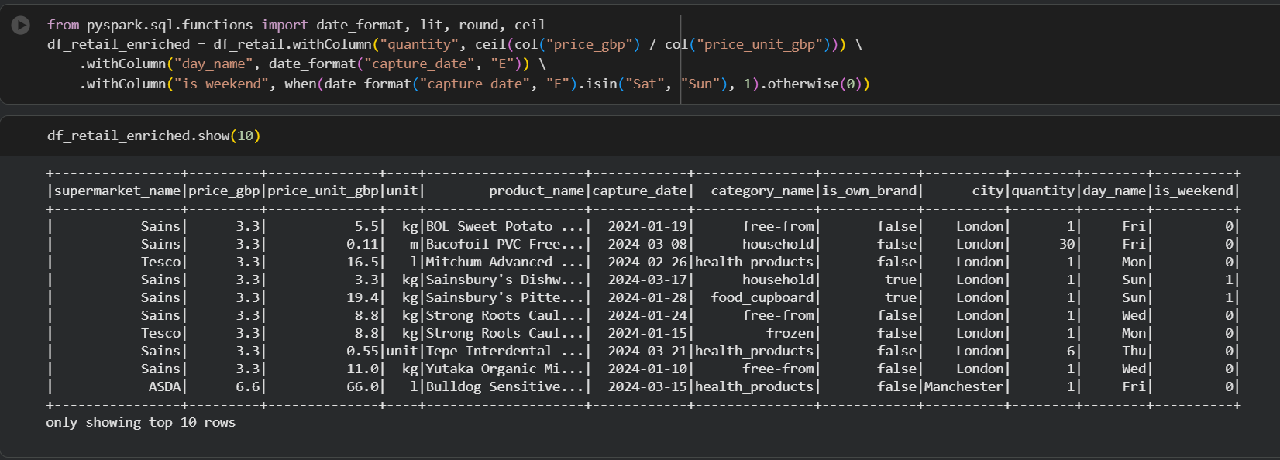

5.5. Restrict stations to the UK geographic bounding box.

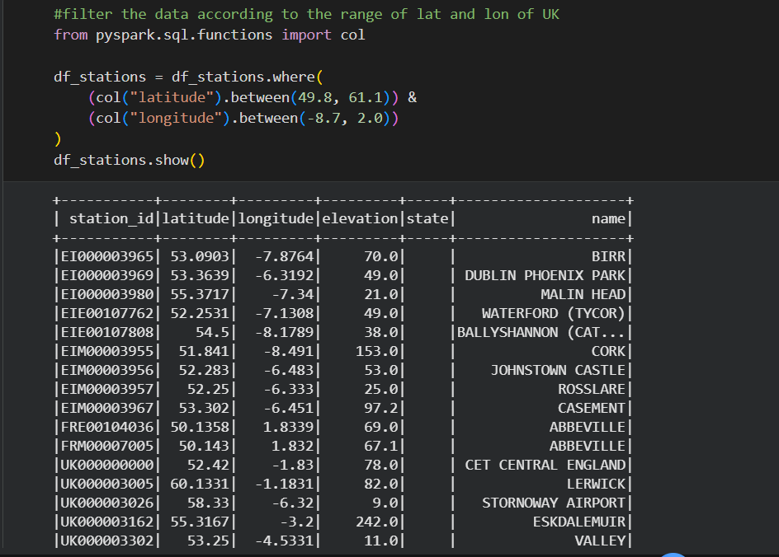
- Filter the full global station list to keep only stations that are physically located in or very near the UK:
  - Latitude between 49.8°N and 61.1°N.
  - Longitude between 8.7°W and 2.0°E.
- This reduces the dataset to UK-relevant stations and improves subsequent performance and accuracy.

5.6. Drop non-UK station codes based on ID pattern.
- Check how many filtered stations do not follow the expected UK station ID pattern (station_id starting with "UK"). There are only a few.
- Enforce the ID convention by keeping only stations whose ID starts with "UK".
- This ensures consistency with the weather and station metadata conventions.
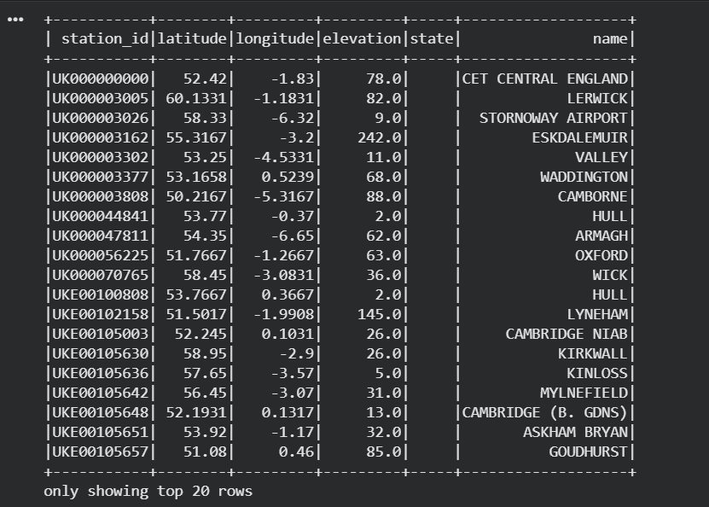
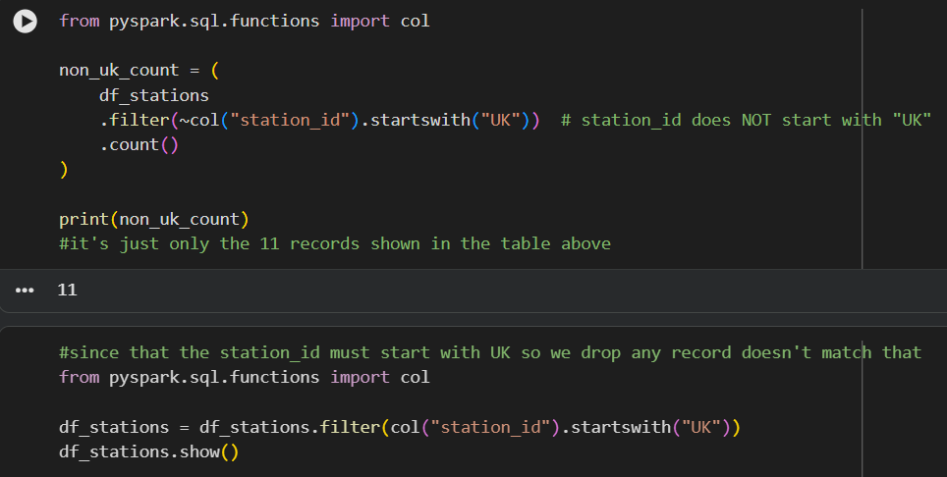

5.7. Prepare city coordinates and clean city names.
- Rename the city coordinate columns to city_lat and city_lng for clarity and to avoid collisions with station coordinates.
- Standardize city names from both sources (gb.csv and retail data):
- Convert to lowercase.
- Trim surrounding whitespace.
- Store in city_clean.
- Filter the list of UK cities to only those that actually appear in the retail dataset:
- Inner join on city_clean between df_cities_clean and distinct retail cities.
- The result df_cities_filtered contains only cities relevant for the combined retail + weather analysis.
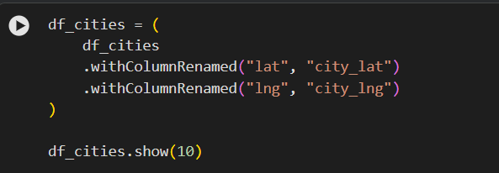
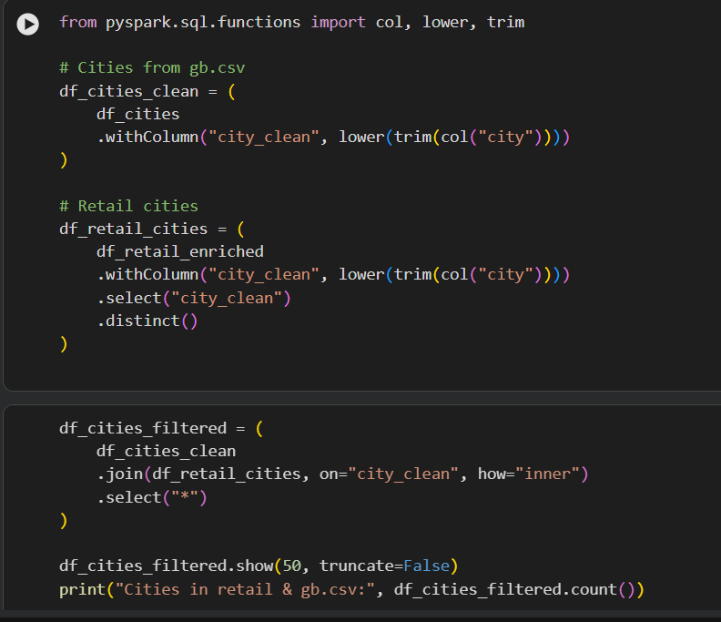

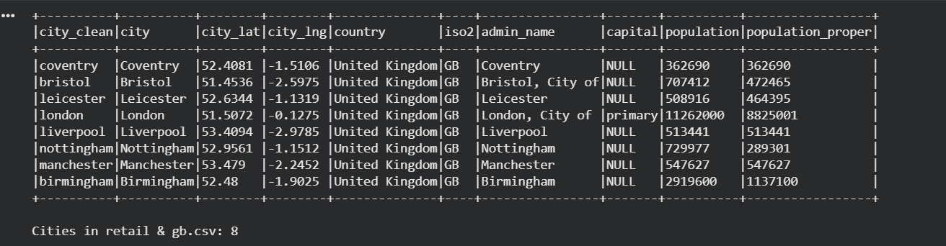

5.8. Map each station to its nearest UK city (Haversine distance)
- Compute the geographic distance between each UK station and each UK city using the Haversine formula:
  - Convert station and city coordinates to radians.
  - Compute angular distance c, then convert to linear distance in kilometers (distance_km).
- Use a window partitioned by station_id ordered by distance_km to rank cities by proximity.
- Keep only the nearest city per station:
  - stations_with_city has one row per station, enriched with nearest_city and distance_km.
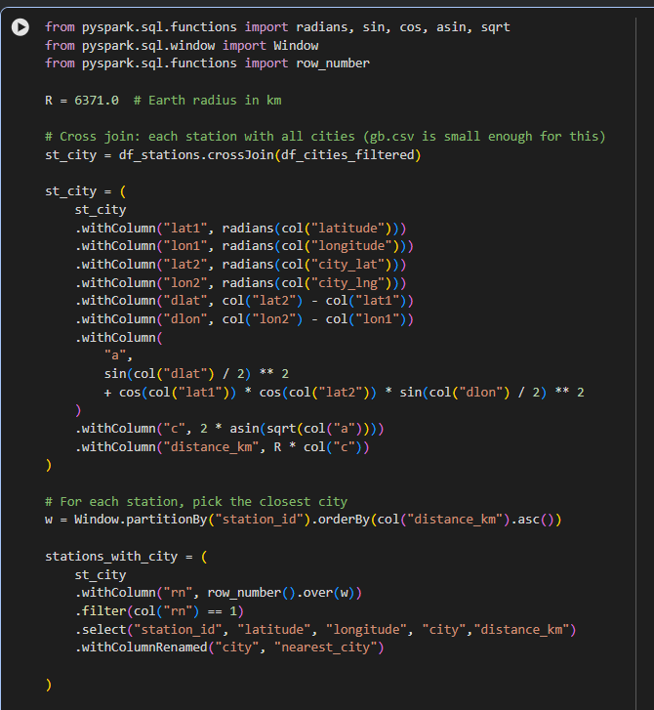

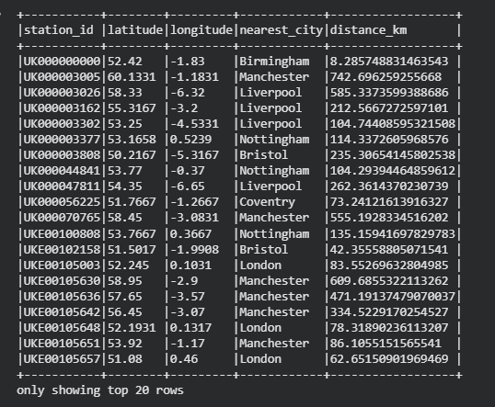

5.9. Normalize city names in retail and stations, and add transaction IDs.
- Standardize the city key across retail and station–city mapping:
- Add city_clean to both df_retail_enriched and stations_with_city by lowercasing and trimming the city name.
- Ensure capture_date is a proper DateType (not string or timestamp with time).
- Introduce a synthetic transaction identifier transc_id for each retail row as transc_<running_number>, ordered by capture_date. This provides a convenient unique key for individual transactions.
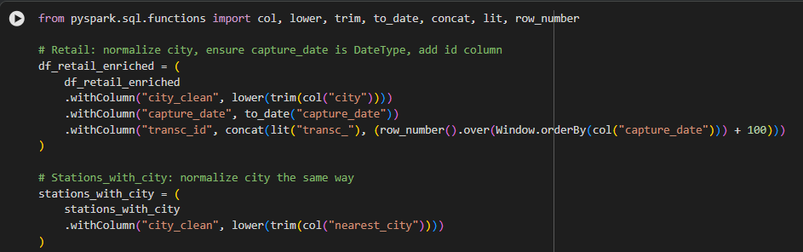

5.10. Categorize weather by temperature and precipitation.
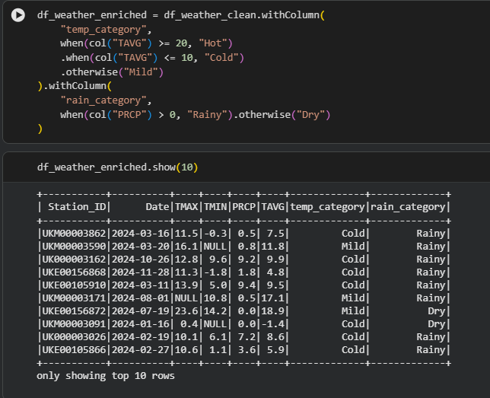
- Enrich the cleaned weather data with categorical features:
  - temp_category:
    - "Hot" if TAVG >= 20°C
    - "Cold" if TAVG <= 10°C
    - "Mild" otherwise.
  - rain_category:
    - "Rainy" if PRCP > 0
    - "Dry" if PRCP == 0.
- Add a normalized date column date derived from the original Date column to use as a join key.

5.11. Choose the best station per city (closest station)
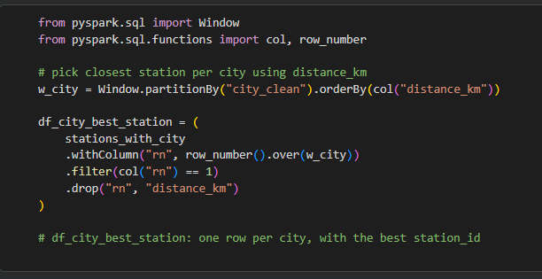
- Some cities may be linked to multiple nearby stations. For each city_clean:
- Rank stations by distance_km (closest first).
- Keep only the closest station per city.
The resulting df_city_best_station has a single station_id representing the primary station for each city.
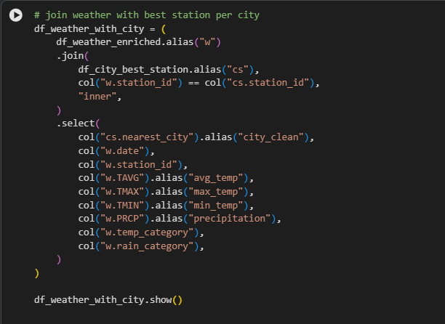
5.12. Attach weather to cities using the best station.
- Join daily weather (df_weather_enriched) with df_city_best_station on station_id.
- For each (city, date) pair, obtain:
- numeric weather metrics: avg_temp, max_temp, min_temp, precipitation.
- categorical attributes: temp_category, rain_category.
- The resulting df_weather_with_city dataset is a city–date-level weather table.
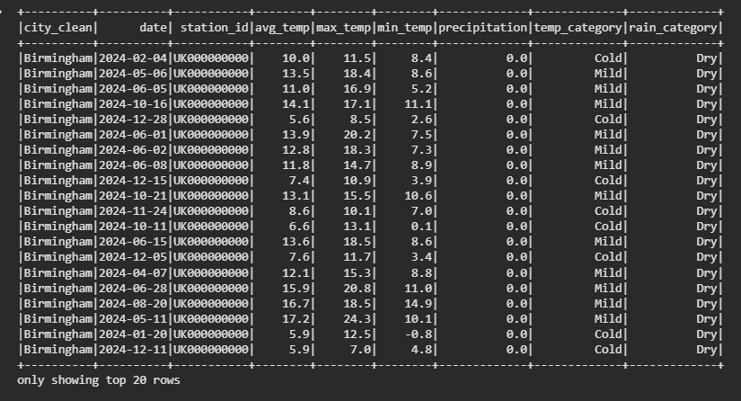

5.13. Normalize join keys and join retail with weather.
- Create consistent join keys in both datasets:
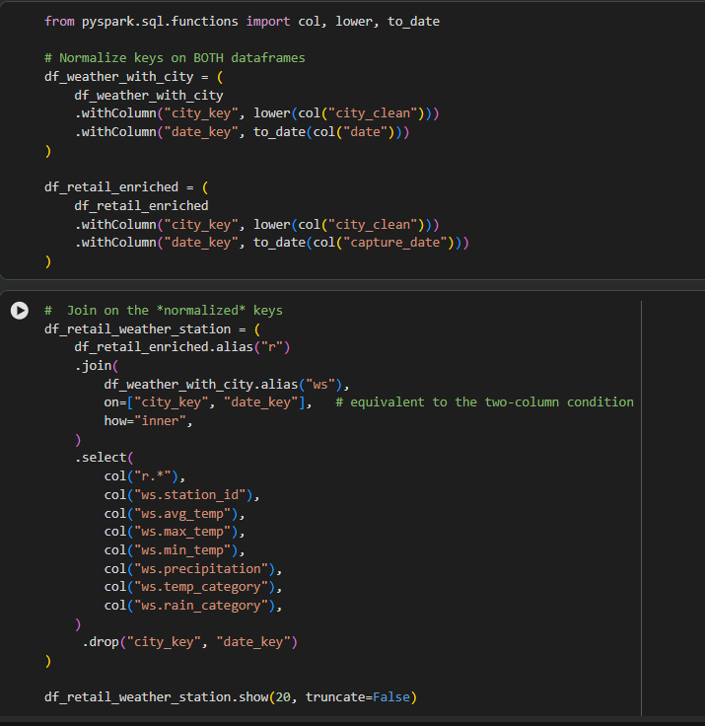
- city_key = lowercased city_clean.
- date_key = date representation of date (for weather) and capture_date (for retail).
- Perform an inner join on (city_key, date_key) to attach the correct weather conditions to each retail transaction.
- Drop the helper join keys afterwards to keep the schema clean.
- The resulting DataFrame df_retail_weather_station contains a transaction-level view with:
- transactional details (product, price, quantity, supermarket, etc.)
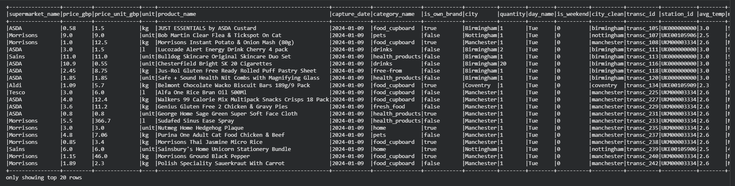
- and the corresponding city-level weather for that date.

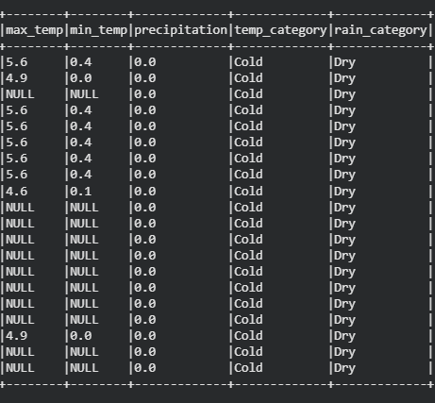

5.14. Build Dim_Date dimension
- Derive a date dimension from distinct capture_date values.
- Create a surrogate key date_id as integer yyyyMMdd.
- Add common calendar attributes:
- year, month, day, day_name, is_weekend.
- Rename capture_date to full_date to clearly represent the full calendar date in the dimension table.
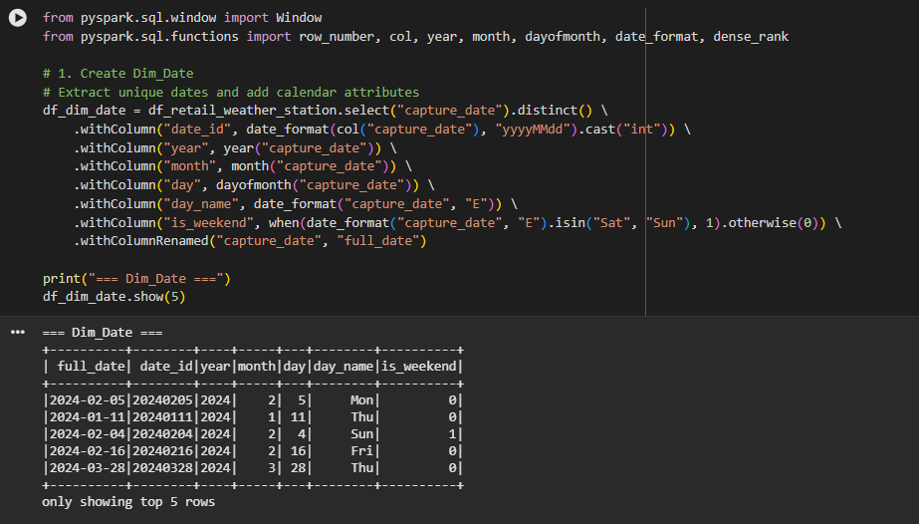

5.15. Build Dim_Product dimension
- Construct a product dimension with one row per unique combination of:
- product_name, category_name, unit, price_unit_gbp.
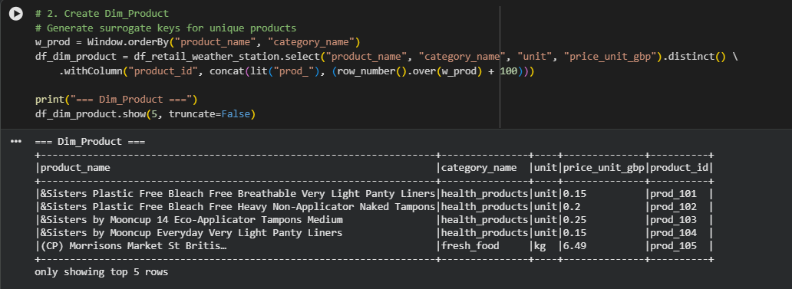
- Assign a surrogate product key product_id using row_number over a deterministic ordering.
- This enables referencing products in the fact table using compact IDs instead of long text fields.

5.16. Build Dim_Supermarket dimension
- Create a supermarket dimension with one row per supermarket_name.
- Generate a surrogate key supermarket_id using row_number.
- This supports star-schema style joins from the fact table to supermarket attributes.
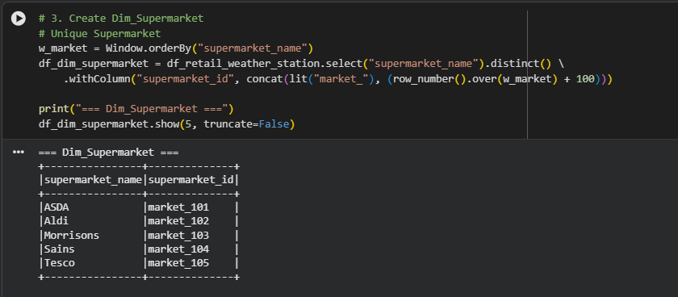

5.17. Build Dim_Station dimension
- Reuse the stations_with_city DataFrame as a station dimension:
  - Includes station ID, coordinates, nearest city, and (optionally) distance to city.
- This dimension allows analysis by station and geography (closest city).

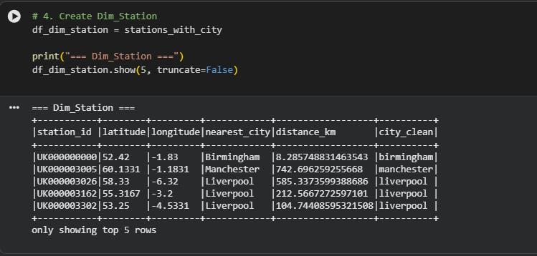

5.18. Build Fact_Sales fact table
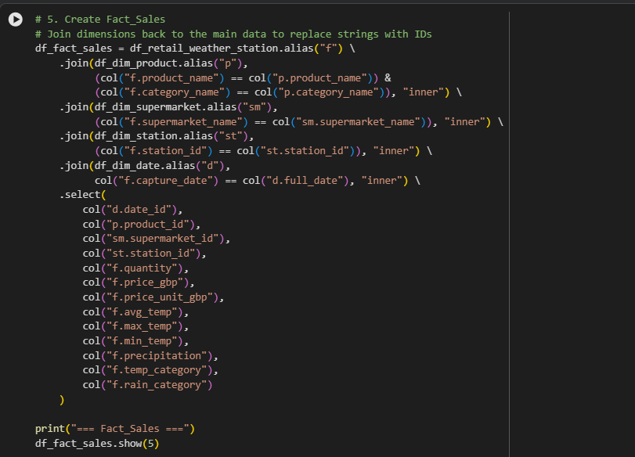
- Construct the Fact_Sales table by joining the enriched transaction data with all dimensions:
- Join to Dim_Product on product_name + category_name.
- Join to Dim_Supermarket on supermarket_name.
- Join to Dim_Station on station_id.
- Join to Dim_Date on capture_date = full_date.
- Select and keep:
- Dimension keys: date_id, product_id, supermarket_id, station_id.
- Measures: quantity, price_gbp, price_unit_gbp.
- Weather measures and categories: avg_temp, max_temp, min_temp, precipitation, temp_category, rain_category.
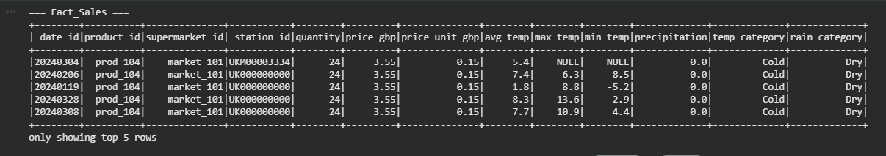
- This fact table represents the core star-schema grain:
one row per retail transaction × day × product × supermarket × station with attached weather.

6.Snowflake Setup and Star Schema Creation
To make the star-schema available in Snowflake and ready for loading from Spark, I created a small dedicated Snowflake environment using the following steps:

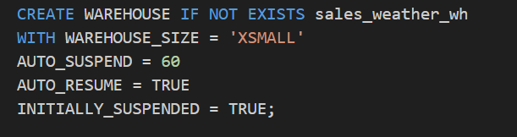
Provisioned a virtual warehouse

This creates a cost-efficient XSMALL warehouse called sales_weather_wh that automatically suspends after 60 seconds of inactivity and resumes when new queries arrive.

Created a logical container for the project
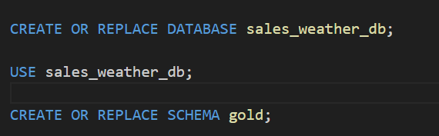

The database sales_weather_db and schema gold are the home for all analytics tables related to the Sales + Weather project.

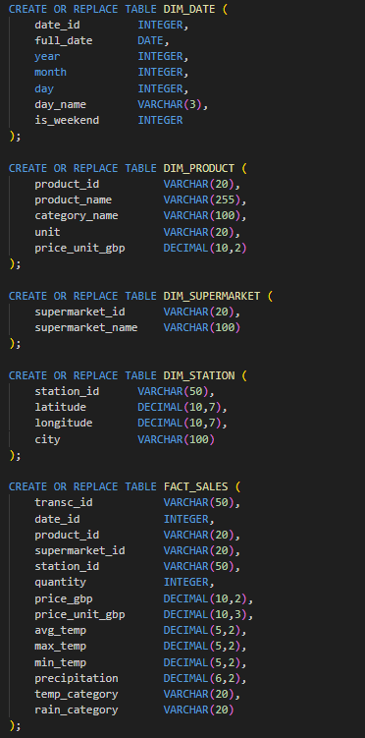
Defined the star-schema tables
Each table mirrors the design in the data-model slide:
DIM_DATE, DIM_PRODUCT, DIM_SUPERMARKET, and DIM_STATION hold the dimension attributes, while FACT_SALES stores measures (quantity, prices) and weather metrics with foreign keys to all four dimensions.

Created a technical user for Spark
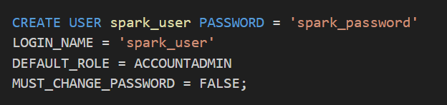

The spark_user account is used by the Spark connector to load data from the PySpark jobs into Snowflake. Here is the snowflake connection parameters with pyspark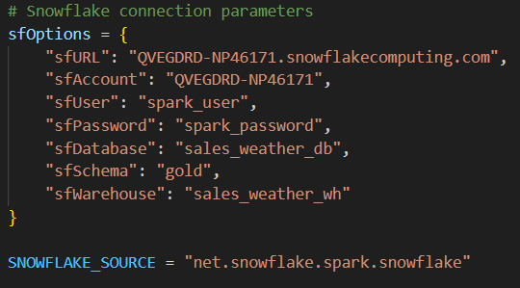
Granted the required privileges
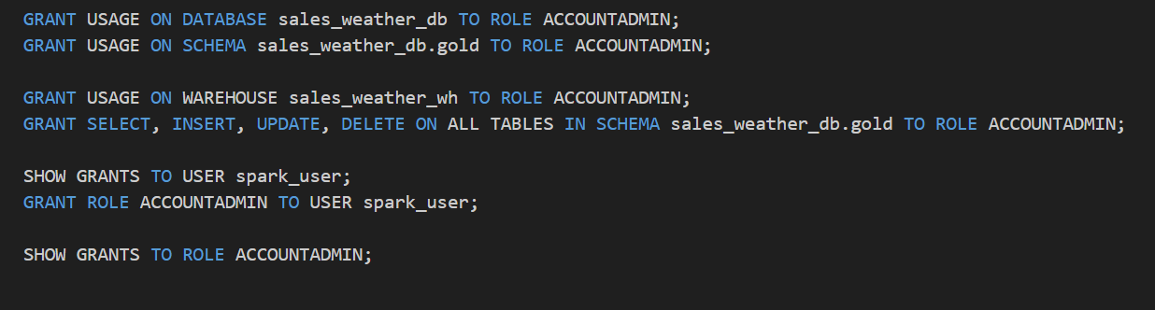

These grants allow the chosen role (and therefore spark_user) to use the warehouse, access the database and schema, and read/write all tables in the gold schema.
After running this script, the Snowflake environment contained empty star-schema tables, and the spark_user account could be used by PySpark to load the dimension and fact data produced in the big data lab.
Load the Fact and Dimensions into Snowflake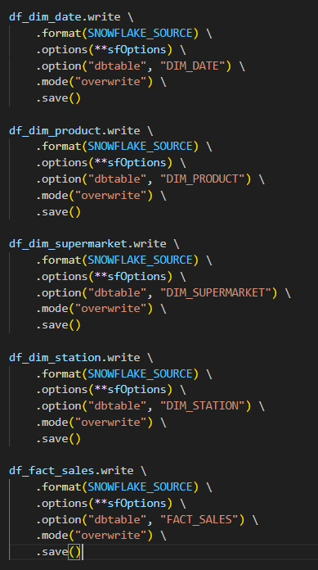

7. Orchestration with Airflow:
Created ‘final_project_dag.py’ contains 4 tasks:
1. Task 1: Send data to Nifi using volumes we mentioned above
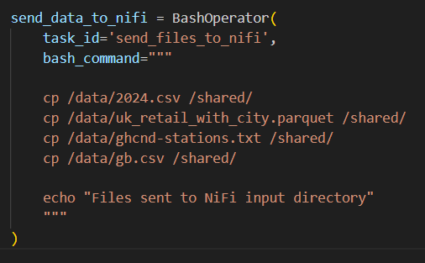
2. Task 2: verify that the HDFS contains all raw data coming from NiFi
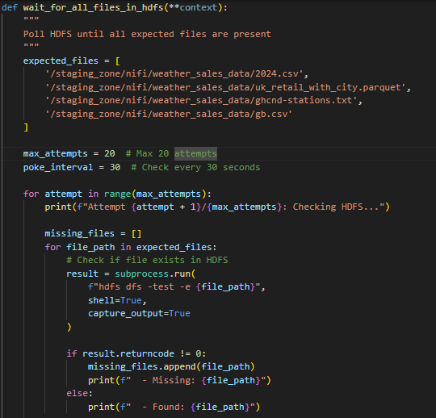 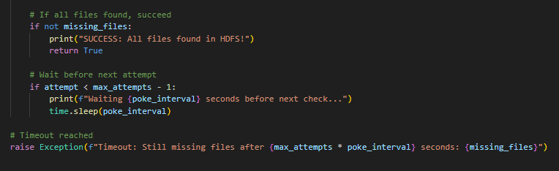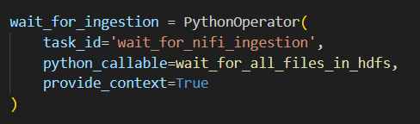
3. Task 3: run the transformations spark job:
- This transforms the raw data in HDFS (to be ready for applying the star
schema model) and load it again into HDFS ‘silver’ directory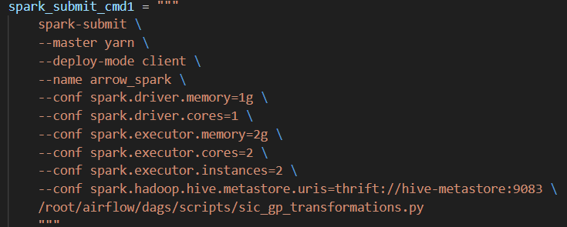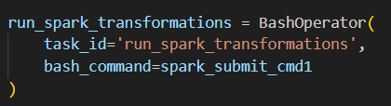

4. Task 4: run spark job for applying the star schema model
- This creates the fact and dimensions tables then load them into the
Snowflake Data warehouse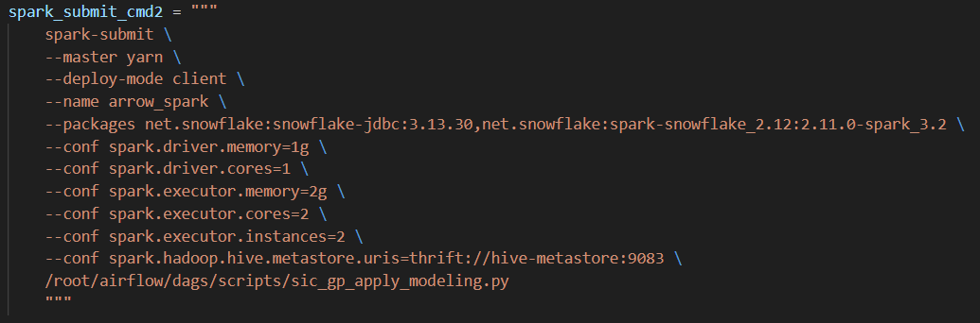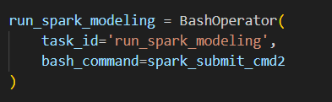
5. Run the final dag: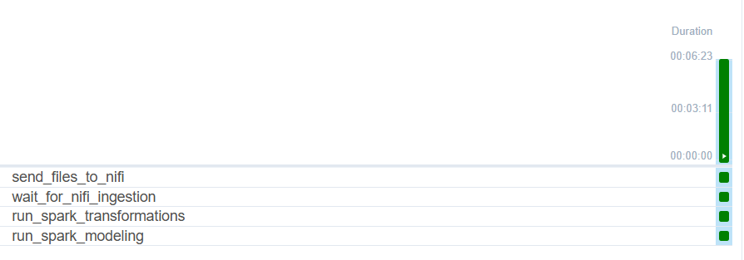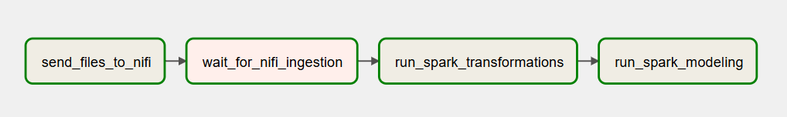
6. Verify the tables successfully loaded into Snowflake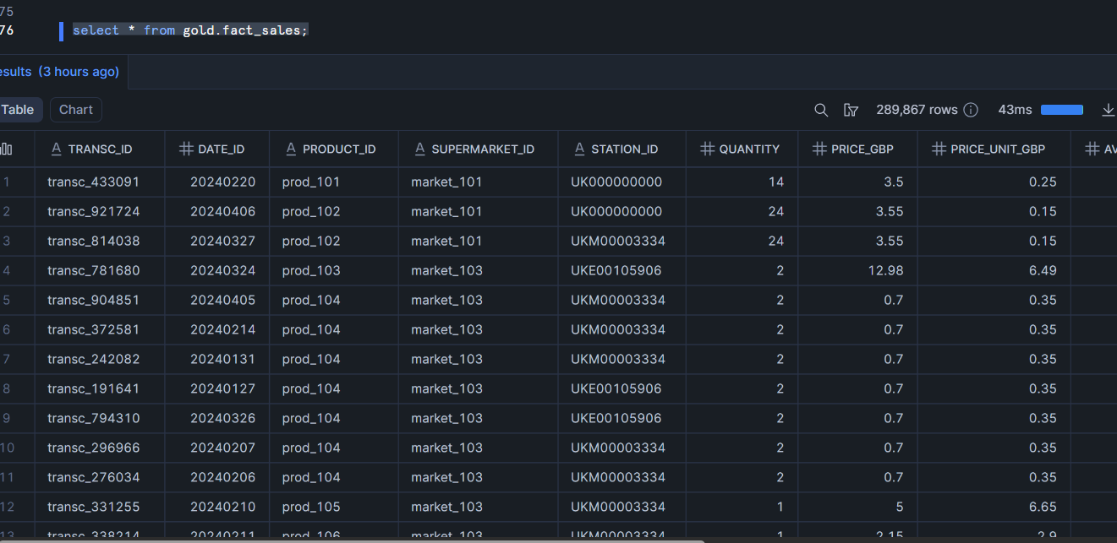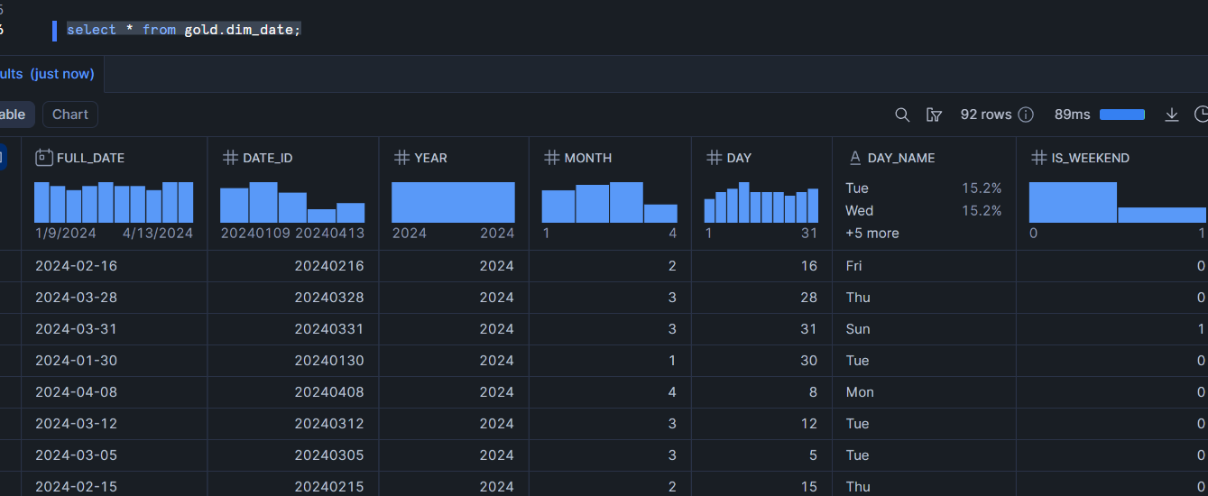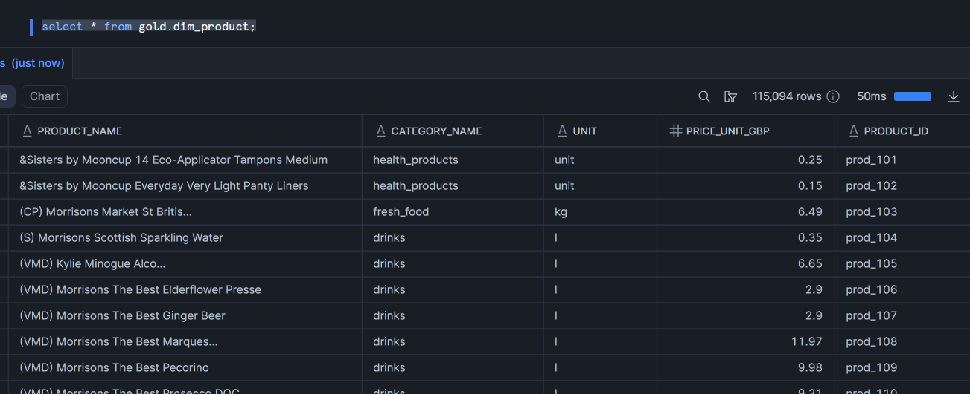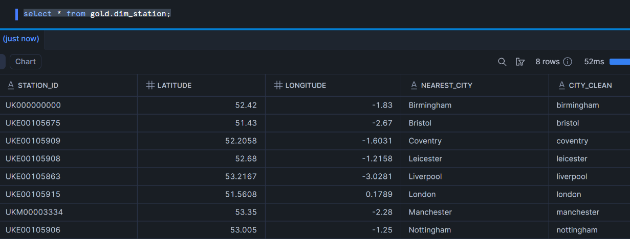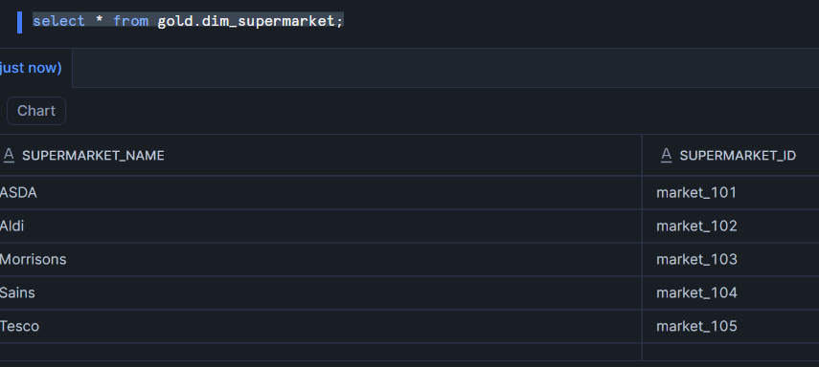

8. Dashboard
Key Metrics (Top Row):
- 9.52M: Total number of products in the dataset.
- 125.72K: Number of distinct products available.
- 49.80M: Total sales revenue generated.
- 438.87M: Average unit price of products.
- 37M: Total population covered by the analysis.
Charts & Insights:
- Total Products per Supermarket (Pie Chart):
Sainsbury's has the largest product share (27.32%), followed by ASDA (25.8%). Morrisons and Tesco have similar shares, while Aldi has the smallest share (4.9%).
- Sales Per Supermarket and National Brands (Bar Chart):
Shows total sales for each supermarket, split by whether the product is a national brand ("True") or not ("False"). Sainsbury's and ASDA have significant sales from national brands.
- Product per City (Pie Chart):
London has the highest percentage of products (16.16%), followed by Manchester (11.87%) and Bristol (10.95%).
- Sum of Price GBP by Category Name and Rain Category (Bar Chart):
Compares total price/sales for product categories (home, health products, drinks, food cupboard) based on weather conditions ("Dry" vs. "Rainy"). "Home" category sees significantly higher sales during dry weather.
- Total Sales per City and Supermarket (Stacked Bar Chart):
  - Insight: Displays the distribution of total sales across different cities, broken down by supermarket contribution.
  - Sheffield: Morrisons contributes the most to sales.
  - London: Sainsbury's and Tesco are dominant.
  - Manchester: ASDA has a large share.

This dashboard provides a comprehensive view of the retail landscape, highlighting key performance indicators such as total products, sales volume, and average pricing. It segments data by supermarket, city, product category, and even weather conditions ("Dry" vs. "Rainy"), offering valuable insights into market share, brand performance, and regional sales trends. Key takeaways include Sainsbury's leading product share and the impact of dry weather on home product sales.